**Discovery 8: Implement OSPF Tuning**

**Introduction**

In this discovery, you will learn how to tune the behavior of OSPF. You will first start by investigating the network topology and the current OSPF configuration. You will then enable passive interfaces on DIST and BR, configure OSPF default routing, investigate Equal-Cost Multipath load balancing, and adjust OSPF default and interface cost values.

The discovery is prepared with the devices that are represented in the topology diagram and configured according to the information in the Job Aids section. All devices have their basic configurations in place, including hostnames and IP addresses. OSPF has been configured on all five routers. Router BR is advertising four external networks into OSPF.

Your configuration tasks are as follows:

* Investigate OSPF Configuration
* Configure OSPF passive interfaces
* Configure OSPF default routing and investigate ECMP load balancing
* Adjust OSPF cost calculations

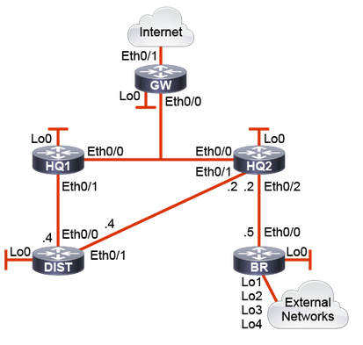

**Task 1: Investigate OSPF Configuration**

**Activity**

Implement OSPF TuningEnterprise/CCNP/Enterprise_Core/ENCOR/v1.0/ELT_VIDEOS/ENCOR10_08-03_Implement-OSPF-Tuning_001.mp43Play Transcript ID4405040template_version4.1.1Enterprise/CCNP/Enterprise_Core/ENCOR/v1.0/ELT_VIDEOS/ENCOR10_08-03_Implement-OSPF-Tuning_001.vtt

**Step 1:** On DIST, verify the OSPF configuration using the show ip ospf neighbor, show ip protocols, and show ip route OSPF commands.

On the DIST router, enter the following commands:

DIST# show ip ospf neighbor

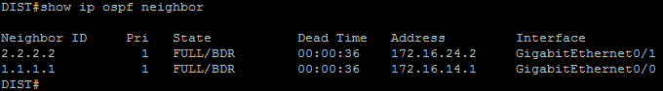

DIST# show ip protocols

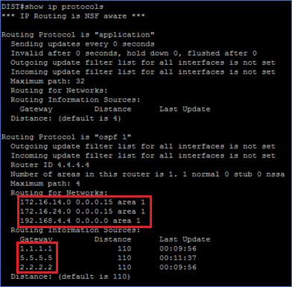

DIST# show ip route ospf

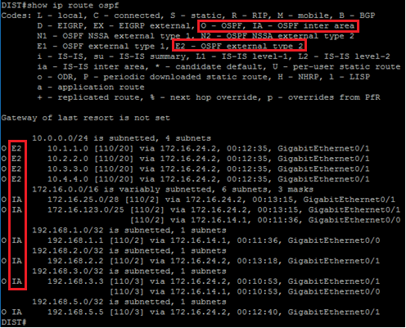

DIST has two OSPF neighbors: HQ1 with router ID 1.1.1.1, and HQ2 with router ID 2.2.2.2. They are both BDR on the segments connected to DIST. DIST was elected DR on these segments since its router ID of 4.4.4.4 is higher than its neighbors and all routers had a default OSPF interface priority value of 1.

OSPF is enabled on DIST for all three directly connected subnets in Area 1 and it is receiving routing information from HQ1, HQ2, and BR.

The routing table shows that DIST is learning four OSPF external networks (E2) that are being advertised by the BR router. DIST is using the path through HQ2 to reach these external networks. All other OSPF routes are inter-area entries (IA) from Area 0 and area 2.

**Step 2:** On the BR router, verify the OSPF configuration using the show ip ospf neighbor, show ip ospf interface GigabitEthernet 0/0, show ip protocols, and show ip route ospf commands.

On the BR router, enter the following commands:

BR# show ip ospf neighbor

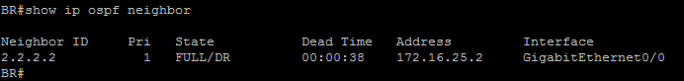

BR# show ip ospf interface GigabitEthernet 0/0

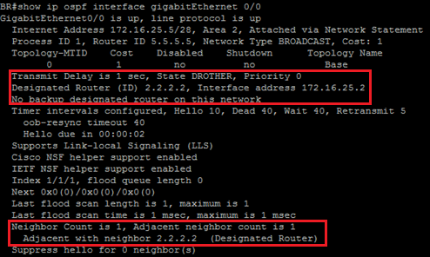

BR# show ip protocols

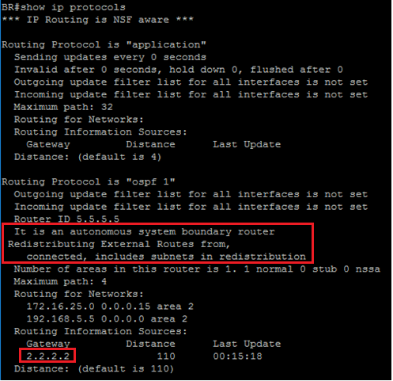

BR# show ip route ospf

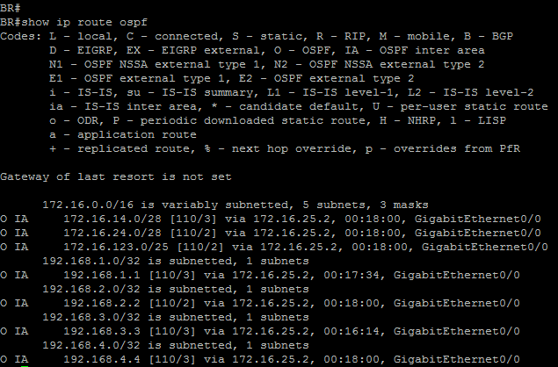

BR has only one OSPF neighbor: HQ2 with router ID 2.2.2.2. HQ2 is DR on the shared broadcast segment with BR since an OSPF priority value of 0 was preconfigured on BR’s GigabitEthernet 0/0 interface. Since BR is not participating in the DR/BDR election process, it has taken the DROTHER state.

BR is reported as being an Autonomous System Boundary Router since it is redistributing connected interfaces as external routes. Redistributed routes will be advertised and flooded throughout the OSPF domain using Type-5 AS External LSAs. By default, these routes will appear in all other routers as O E2 routing table entries.

OSPF is enabled on BR for two of its directly connected subnets in area 2 and it is receiving routing information from HQ2.

The routing table shows that BR is learning all the inter-area (IA) routes that area being advertised from Area 0 and Area 1.

**Step 3:** On the GW router, verify the OSPF configuration using the show ip ospf neighbor, show ip ospf interface GigabitEthernet 0/0, show ip protocols, and show ip route ospf commands.

On the GW router, enter the following commands:

GW# show ip ospf neighbor

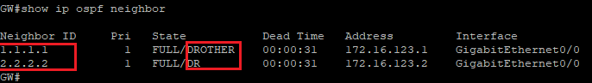

GW# show ip ospf interface GigabitEthernet 0/0

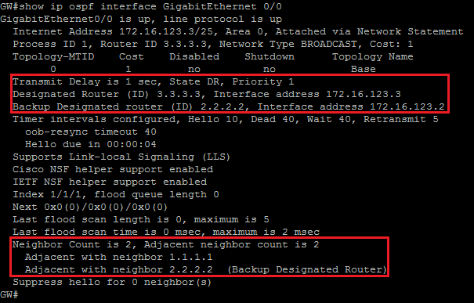

GW# show ip protocols

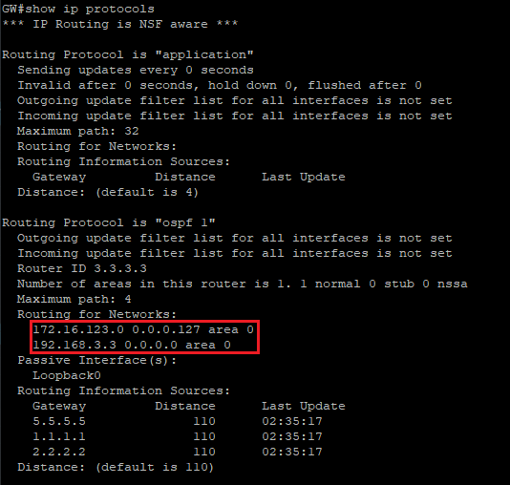

GW has two OSPF neighbor: HQ1 with router ID 1.1.1.1 and HQ2 with router ID 2.2.2.2. GW is DR on the shared broadcast segment with HQ1 and HQ2. Since all three routers have a default

OSPF priority of 1, the OSPF router ID was used as a tie-break. GW, with a router ID of 3.3.3.3 was elected DR, while HQ2 with a router ID of 2.2.2.2 was elected BDR. HQ1 (1.1.1.1) took on the role of DROTHER on the segment.

OSPF is enabled on GW for two of its directly connected subnets in Area 0 and it is receiving routing information from HQ1, HQ2, and BR.

The routing table shows that GW is learning four OSPF external networks (E2) that are being advertised by the BR router. GW is using the path through HQ2 to reach these external networks. All other OSPF routes are either intra-area (O) or inter-area entries (IA) from Area 0, Area 1 and area 2.

**Task 2: Configure OSPF Passive Interfaces**

**Activity**

OSPF Passive Interfaces

Passive interface configuration is a common method for hardening routing protocols and reducing the use of resources. It is also supported by OSPF.

* Passive interfaces in OSPF suppress inbound and outbound OSPF packets on the interface.
* Passive interfaces harden routing protocol and reduce bandwidth and router CPU usage.
* Configure a passive interface on interfaces without any OSPF peers.

Use the passive-interface default router configuration command to enable this feature for all interfaces.

When you configure a passive interface under the OSPF process, the router will stop sending and receiving OSPF hello packets on the selected interface. Use passive interface configuration only on interfaces where you do not expect the router to form any OSPF neighbor adjacency. You can either configure a specific interface as passive or turn on the passive interface setting as default and then identify interfaces which should be configured with the no passive-interface configuration command.

**Step 1:** On DIST, set the Loopback 0 interface as passive. On BR, set all interfaces as passive, except the interface that connects to HQ2. Passive interfaces have already been preconfigured on GW, HQ1, and HQ2.

On the DIST and BR router, enter the following commands:

DIST(config)# router ospf 1

DIST(config-router)# passive-interface Loopback 0



BR(config)# router ospf 1

BR(config-router)# passive-interface default

BR(config-router)#

BR(config-router)# no passive-interface GigabitEthernet 0/0

BR(config-router)#

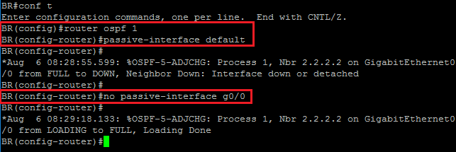

Notice that during configuration of passive interfaces on BR, a syslog message indicates that the neighbor adjacency is down until that feature is disabled for the GigabitEthernet 0/0 interface.

**Step 2:** Verify the passive interface configuration on DIST and BR using the show ip protocols command.

On the DIST and BR router, enter the following commands:

DIST# show ip protocols

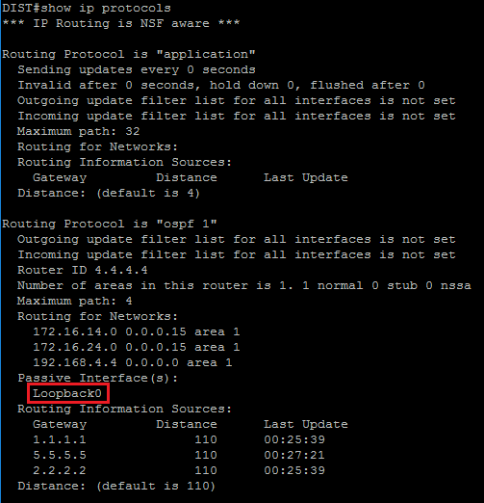

BR# show ip protocols

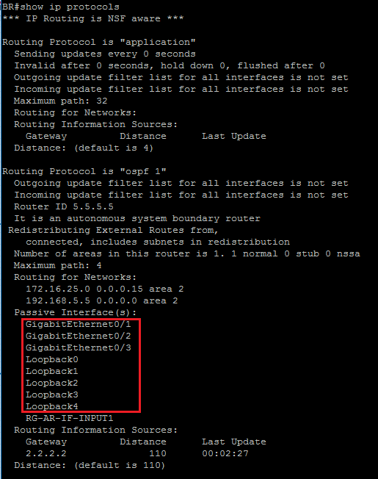

Passive interfaces have been configured for the DIST Loopback 0 interface and for all the BR interfaces except GigabitEthernet 0/0.

**Step 3:** Verify the OSPF neighbor table on BR.

On the BR router, enter the following command:

BR# show ip ospf neighbor

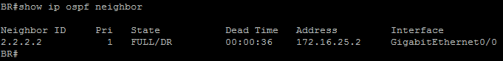

The output confirms that the neighbor adjacency with HQ2 is re-established since the GigabitEthernet 0/0 interface was excluded from the passive interface configuration.

**Task 3: Configure OSPF Default Routing and Investigate ECMP Load Balancing**

**Activity**

**OSPF Default Routing**

To be able to perform routing from an OSPF domain toward external networks or toward the Internet, you must either know all the destination networks or create a default route noted as 0.0.0.0/0.

* Injection of a default route using Type-5 LSA:
  + Configured on the uplink ASBR with default-information originate

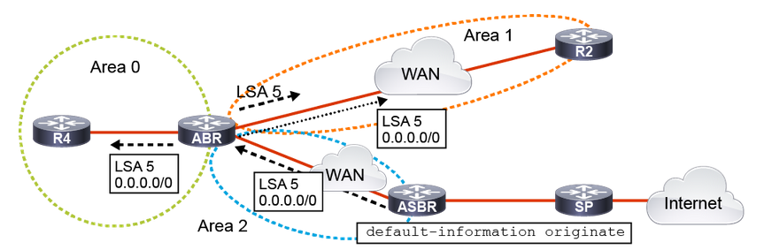

The default routes provide the most scalable approach. Default routing guarantees smaller routing tables. Fewer resources are consumed on the routers. There is no need to recalculate the SPF algorithm if one or more networks fail.

To implementing default routing in OSPF, you can inject a default route using a Type-5 LSA.

This is implemented by using the default-information originate command on the uplink ASBR, as shown in the figure. The uplink ASBR connects the OSPF domain to the upstream router in the SP network. The uplink ASBR generates a default route using a Type-5 AS External LSA, which is flooded in all OSPF areas except the stub areas.

This is implemented by using the default-information originate command on the uplink ASBR, as shown in the figure. The uplink ASBR connects the OSPF domain to the upstream router in the SP network. The uplink ASBR generates a default route using a Type-5 AS External LSA, which is flooded in all OSPF areas except the stub areas.

GW(config-router)# default-information originate ?

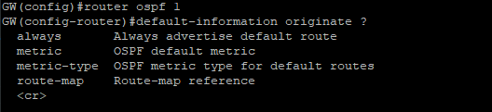

* always — Injects the default LSA 5 even if no default route exists on ASBR
* metric — Sets the OSPF cost for the default route
* metric-type — Defines the metric type (E1/E2) for the default route
* route-map — Matches conditions and sets parameters

You can advertise 0.0.0.0/0 into the OSPF domain when the advertising router already has a default route. Use the default-information originate command to allow the ASBR to originate a Type-5 default route inside the OSPF AS.

You can use different keywords in the configuration command. To advertise 0.0.0.0/0 regardless of whether the advertising router already has a default route, add the keyword always to the default-information originate command.

The router automatically becomes an ASBR when you use the default-information command.

You can also use a route map to define dependency on any condition inside the route map. The metric and metric-type options allow you to specify the OSPF cost and metric type of the injected default route.

**Step 1:** On GW, verify the routing table for the presence of a static default route and test connectivity to the Internet-hosted address 10.1.1.254.

On the GW router, enter the following commands:

GW# show ip route | include 0.0.0.0/0



GW# ping 10.1.2.1

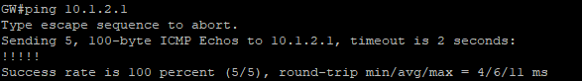

A default route is already preconfigured on GW and access to the 10.1.2.1 address is confirmed.

**Step 2:** Use the default-information originate command on GW to advertise a default route into the OSPF domain. Verify that the default route is being correctly advertised by GW and received by DIST and BR.

On the GW, DIST, and BR routers, enter the following commands:

GW(config)# router ospf 1

GW(config-router)# default-information originate



GW# show ip ospf

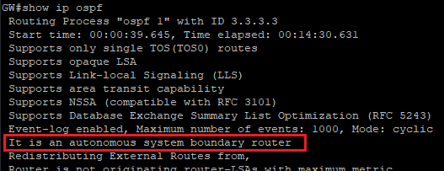

GW# show ip ospf database external 0.0.0.0

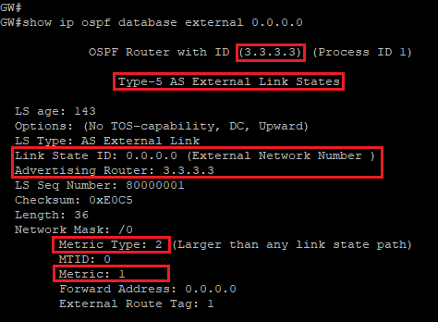

DIST# show ip route

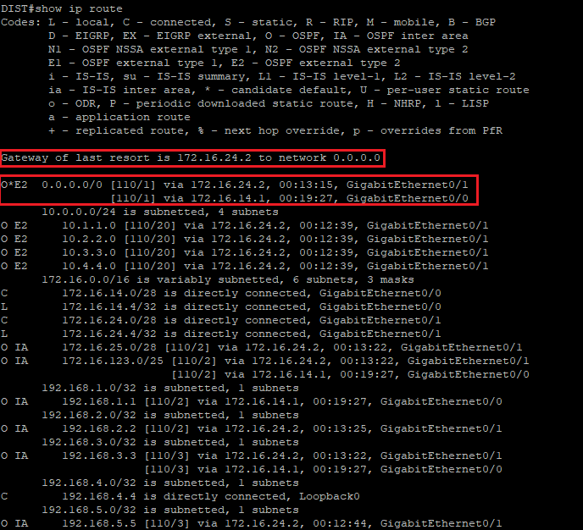

DIST# show ip route 0.0.0.0

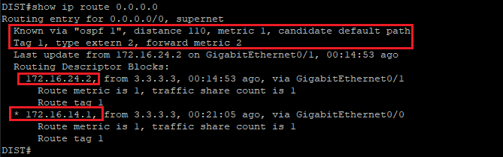

BR# show ip route

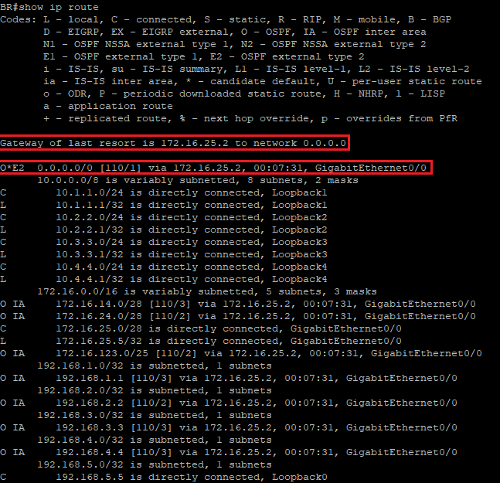

OSPF is now treating GW as an ASBR since it is originating a Type-5 AS External LSA for the 0.0.0.0/0 default route. The default route is advertised as an external metric Type 2 (E2) with a constant metric value of 1. As an E2 route, the metric value, or cost, will always remain 1 as the route is propagated across the OSPF domain.

DIST is receiving the Type-5 LSA from both HQ1 and HQ2. DIST adds both routes to the routing table and enables Equal-Cost Multipath load balancing. The reason that multiple routes are installed in DIST’s routing table is that the route type (E2), the metric (1), and the forward metric (20) are all a tie. If any of these fields were to change, the path selection would change. The forward metric denotes the cost to the ASBR advertising the default route. In this case, the ASBR is GW. All GigabitEthernet interfaces have a default cost of 10 in OSPF. Regardless of the path it takes to GW, DIST must cross two GigabitEthernet segments to reach the ASBR making the total forwarding cost 20.

BR is also receiving the Type-5 LSA and has added the default route to its routing table as an E2 entry with a cost of 1.

**Step 3:** Using the ping and traceroute commands, test connectivity to the Internet from DIST and BR.

On the DIST and BR routers, enter the following commands:

DIST# ping 10.1.2.1

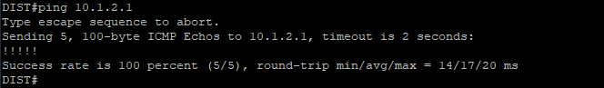

DIST# traceroute 10.1.2.1 probe 8

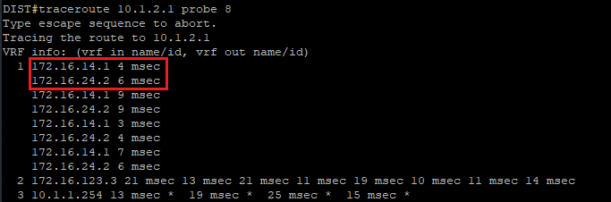

BR# ping 10.1.2.1

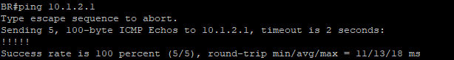

BR# traceroute 10.1.2.1

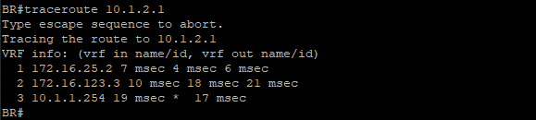

Notice that for DIST to reach the 10.1.2.1 address, the router load balances the first hop across both paths through HQ1 and HQ2. This is more easily viewed by increasing the probe count. Because the traceroute is originated by the router itself, the CEF engine on DIST is bypassed and the packets are process-switched. Process switching means that packets are load-balanced on a per-packet basis instead of per-destination.

Both DIST and BR can reach the 10.1.2.1 address that is three hops away.

**Step 4:** On GW, delete the static default route and investigate the routing tables on DIST and BR.

On the GW, DIST, and BR routers, enter the following commands:

GW# configure terminal Enter configuration commands, one per line. End with CNTL/Z. GW(config)# no ip route 0.0.0.0 0.0.0.0 10.1.1.254



DIST# show ip route

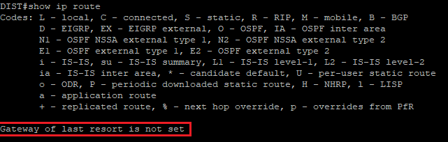

BR# show ip route

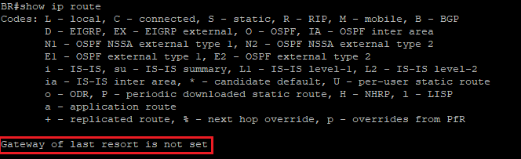

Notice that GW is no longer advertising the default route. Unless otherwise configured, the default-information originate command will only advertise a default route if one exists in the routing table.

**Step 5:** Modify the default-information originate command to allow GW to advertise a default route regardless of whether it already has a default route in its routing table. Verify the routing tables on DIST and BR for the presence on the default route.

On the GW, DIST, and BR routers, enter the following commands:

GW(config)# router ospf 1

GW(config-router)# default-information originate always



DIST# show ip route

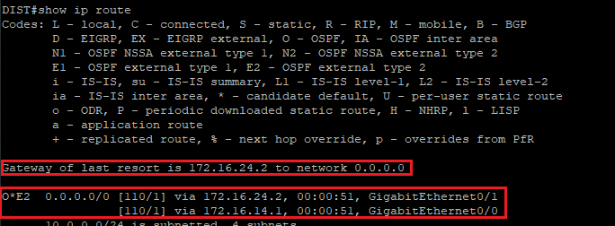

BR#show ip route

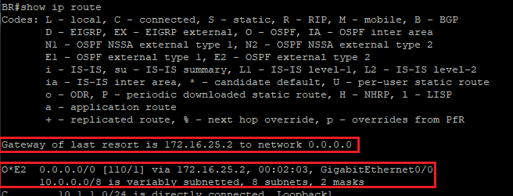

GW is advertising the 0.0.0.0/0 default route throughout the OSPF domain even though it does not have a default route in its own routing table. The result is that all routers in the OSPF domain will forward to GW all packets for which they do not have a more specific route. If GW loses its connection to the Internet, it will drop those packets and return a destination network unreachable ICMP message.

**Step 6:** Verify connectivity to 10.1.2.1 from DIST and BR

On the DIST and BR routers, enter the following commands:

DIST# ping 10.1.2.1

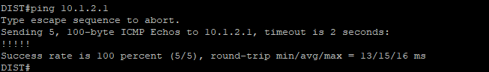

BR#ping 10.1.2.1

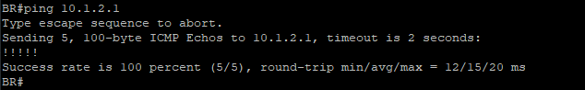

Even though GW does not have a default route, pings to 10.1.2.1 still work because the ASBR has a preconfigured static route to that specific Internet-hosted address.

**Task 4: Adjust OSPF Cost Calculations**

**Activity**

**OSPF Best Path Calculation**

Once LSDBs are synchronized among OSPF neighbors, each router needs to determine on its own the best paths over the network topology.

* SPF calculates the best paths, based on the lowest costs.
* On Cisco IOS Software, OSPF cost reflects the interface bandwidth.
* OSPF cost is automatically determined:
  + Cost = reference bandwidth / interface bandwidth
  + Default reference bandwidth = 100 Mbps
* How can you influence interface cost?
  + By changing the interface bandwidth

When SPF is trying to determine the best path towards a known destination, it compares total costs of specific paths against each other. The paths with the lowest costs are selected as the best paths. The OSPF cost is an indication of the overhead to send packets over an interface.

OSPF cost is computed automatically for each interface that is assigned into an OSPF process, using the following formula:

* Cost = reference bandwidth / interface bandwidth

The cost value is a 16-bit positive number between 1 and 65,535, where a lower value is a more desirable metric. The reference bandwidth is set to 100 Mbps by default.

On high-bandwidth links (100 Mbps and more), automatic cost assignment no longer works, because it would result in all costs being equal to 1. On these links, OSPF costs must be set manually on each interface.

For example, a 64-kbps link gets a metric of 1562, while a T1 link gets a metric of 64. Cost is applied on all router link paths, and route decisions are made on the total cost of a path. The metric is only relevant on an outbound path; route decisions are not made for inbound traffic. The OSPF cost is recomputed after every bandwidth change, and Dijkstra’s algorithm determines the best path by adding all link costs along a path.

**Step 1:** Examine the interface bandwidth and the OSPF cost of the GigabitEthernet interfaces on DIST.

DIST# show interface g 0/0

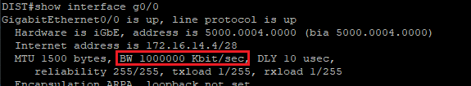

DIST#show interface g0/1

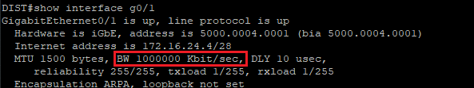

DIST#show ip ospf interface g0/0

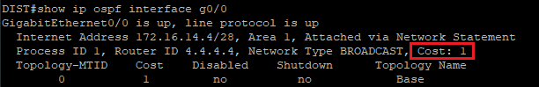

DIST#show ip ospf interface g0/1

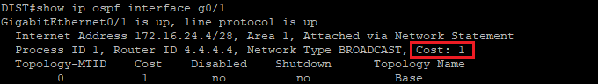

The first command in the output displays the bandwidth of the GigabitEthernet interfaces (10,00000 Kbps), which connects DIST with HQ1 and HQ2. The second output shows that OSPF calculated a cost of 10 for these interfaces. The cost was calculated by dividing the reference bandwidth of 100 Mbps by the actual interface bandwidth.

Default OSPF Costs

OSPF calculates the default interface costs that are based on the interface type and the default reference bandwidth.

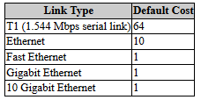

* The default reference bandwidth is set too low for today's common link types.
* Solution: increase reference bandwidth.

The default reference bandwidth of 100 Mbps is not suitable to calculate OSPF costs for links faster than GigabitEthernet. All such links get assigned a cost of 1, and OSPF cannot optimally choose the shortest path because it treats all the high-speed links as equal.

To improve OSPF behavior, you can adjust reference bandwidth to a higher value using the auto-cost reference-bandwidth OSPF configuration command.

**Step 2:** On all routers, change the reference bandwidth to 10 Gbps or 1Gbps.

On each of the routers in the lab, enter the following commands:

(config)#router ospf 1

(config-router)# auto-cost reference-bandwidth 1000000

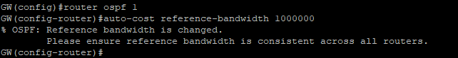

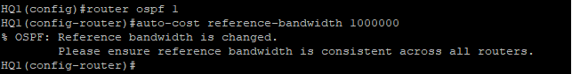

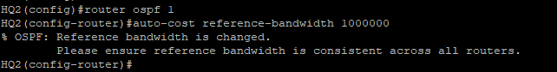

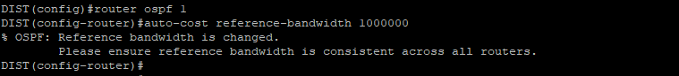

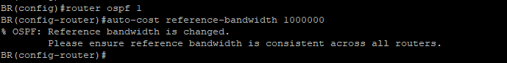

You can change OSPF reference bandwidth under OSPF configuration mode using the auto-cost reference-bandwidth command. The reference bandwidth value is inserted in Mbps.

Also, notice the warning that is displayed by the prompt. Only a consistent reference bandwidth across the OSPF domain ensures that all routers calculate the best paths correctly.

**Step 3:** On DIST, investigate the OSPF link cost of the GigabitEthernet interfaces.

On the DIST router, enter the following commands:

DIST# show ip ospf interface g 0/0

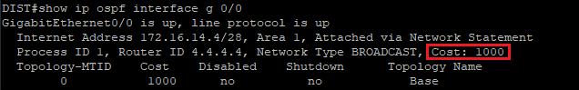

DIST# show ip ospf interface g 0/1

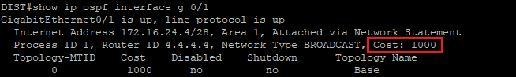The changed OSPF reference bandwidth results in updated OSPF costs for all interfaces. The cost for the GigabitEthernet interfaces has increased from 10 to 1000. The new cost was calculated based on the reference bandwidth of 10 Gbps divided by the interface speed of 10 Mbps.

**Step 4:** On DIST verify the 192.168.3.3/32 entry in the routing table.

On the DIST router, enter the following commands:

DIST# show ip route 192.168.3.3

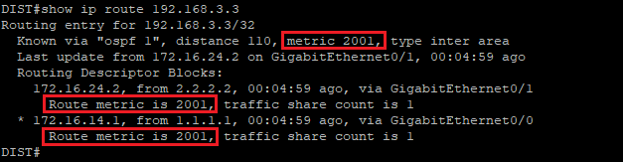

The 192.168.3.3 address is associated with the Loopback 0 interface on GW. The prefix is advertised into Area 0 and is received by DIST as an inter-area Type-3 LSA from ABRs HQ1 and HQ2. Before changing the reference bandwidth, the total cost to reach this address from DIST was 21 (10 for the GigabitEthernet segment to the HQ routers, 10 for the GigabitEthernet segment from the HQ routers to GW, 1 for the Loopback interface on GW). Now, after changing the reference bandwidth, the total cost is 2001 (1000 + 1000 for each GigabitEthernet segment, and + 1 for the Loopback interface).

Thanks to ECMP, DIST is load balancing across the uplinks to HQ1 and HQ2 since the cumulative cost to reach 192.168.3.3 is identical.

**Step 5:** Change the OSPF cost of the GigabitEthernet 0/0 interface on DIST using the ip ospf cost interface command. Verify the OSPF entries in the routing table on DIST and investigate the 192.168.3.3/32 and 0.0.0.0/0 prefixes.

On the DIST router, enter the following commands:

DIST(config)# interface g 0/0

DIST(config-if)# ip ospf cost 500

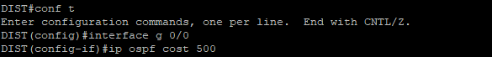

DIST# show ip route ospf

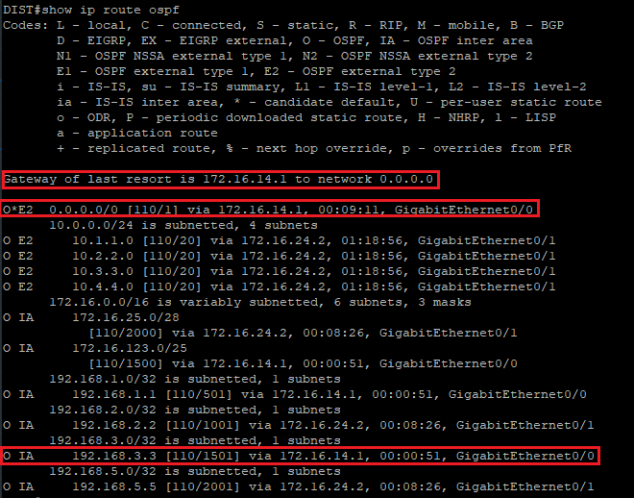

DIST#show ip route 0.0.0.0

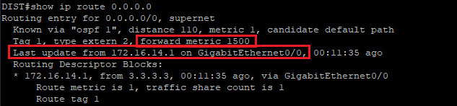

Using the ip ospf cost interface configuration command, you can directly change the OSPF cost of a specific interface. The cost of the interface can be set to a value between 1 and 65535. This command overrides whatever value is calculated based on the reference bandwidth and the interface bandwidth.

Notice that ECMP load balancing is no longer active for the 0.0.0.0/0 entry. Since the forward metric is now much lower through HQ1 (1500), DIST will only use that path to reach the ASBR connected to the Internet.

The total cost for DIST to reach the 192.168.3.3 address in now 1501. The path used to reach GW’s Loopback 0 interface now only flows through HQ1 since its cost is lower than the cost of the path through HQ2 (2001). Like the 0.0.0.0/0 entry, ECMP is no longer active for 192.168.3.3/32 either.

Traffic destined for area 2 or the 10.0.0.0/8 external networks will continue to flow through HQ2 since its forward metric (20) is less than the forward metric calculated through HQ1 (30).